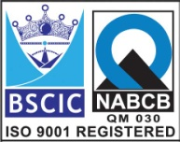****

**“EASCO” Offset Disc Double Flange Butterfly Valve Gear Operate**

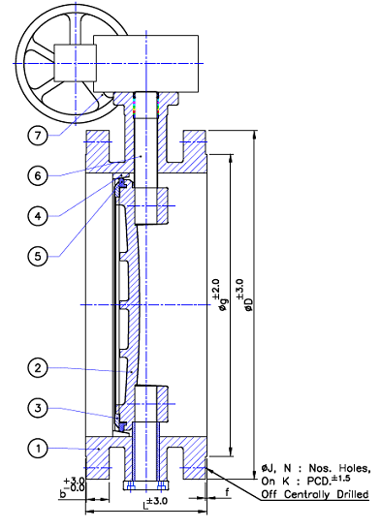

**Technical Data: -**

Manufacturing Std: API609/BS5155/IS 13095

Face to Face: API609 (Short pattern) / BS 5155/IS 13095

End Connation: Flanged End to ANSI B 16.5 RF 150#

Inspection & Testing Std: API 598/BS 6755

**Test Pressure:**

|  |  |
| --- | --- |
| Test | Hydrostatic |
| Pr. Rating | ASA150# |
| Body | 32 Kg/cm2 |
| Seat | 22 Kg/cm2 |

**Part List: - Standard Dimension (150#): -**

|  |  |  |  |  |  |  |  |
| --- | --- | --- | --- | --- | --- | --- | --- |
| **No.** | **Part Name** | **Materials** |  | **Size** | **150** | **200** |  |
| 01 | Body | ASTM A 351 Gr. CF8M | L Face to Face-RF | 140 | 152 |  |
| ǾD | 280 | 345 |  |
| 02 | Disc | ASTM A 351 Gr. CF8M | B | 23.9 | 27 |  |
| ǾG | 215.9 | 269.9 |  |
| 03 | Retainer | SS316 | F | 2 | 2 |  |
| 05 | Body Seat Ring | SS316 | ǾJ | 22.2 | 22.2 |  |
| 06 | Disc Seat Ring | NBR | N | 8 | 8 |  |
| 07 | Shaft | SS316 | K: PCD | 241.3 | 298.5 |  |
| 08 | Gear Box | Std. |  |  |  |  |

**Due to continuous development Program, the design & data given in this leaflet are subject to change without prior notice.**

**ANITA ENGINEERING WORKS**



58-59, Narayan Estate, Opp. Shree Ram Estate, Nr. CMC Ltd. Odhav, Ahmedabad-382415, Gujarat, India

Phone: +91 79 22974101, Fax: +91 79 22875014

Email: eascovalves@gmail.com, eascovalves@yahoo.com, Web: www.eascovalve.com